Experiment 2: Assembler Directives, Linker and Debugger, I/O Ports, and

Macros

Instructional Objectives:
- To continue learning different addressing modes and assembler directives for the HC(S)12.
- To become familiar with the linker parameter file and how constants and variables are allocated to memory.
- To learn how to use general purpose input/output (GPIO) ports.
- To learn how to write a basic macro in assembly.

Introduction:
The first lab experiment for the ECE 362 course is meant to introduce students to the CodeWarrior IDE, as well as how to organize and troubleshoot assembly code for the HC(S)12. As the lab progresses, students will have to apply more intermediate concepts to their code, such as properly using assembler directives and the linker parameter file, how to use the general-purpose input/output ports available on the lab I/O board, and how to write functional macros.

Assembler Directives:
Assembler directives several keywords used to tell the assembler what to do while assembling the source to machine code. They are a handy way of giving meaningful labels to frequently accessed locations in memory, such as ports and registers, as well as frequently used variables and constants. Below are some of the more common directives that will be used in the ECE 362 labs.

Example |  |  | Description
Var1: | ds.b | $10 | Creates an array of 16 ($10) uninitialized bytes in RAM starting at the address  labeled Var1
Var2: | ds.w | 20 | Creates an array of 20 uninitialized words in RAM starting at the address labeled  Var2
Cons1: | dc.b | $F0 | Creates a constant byte value of $F0 in ROM at the address Cons1
Cons2: | dc.w | $1234 | Creates a constant word value of $1234 in ROM at the address Cons2
Port_X: | equ | $282 | Equates the value Port_X to the numerical value of $282
org |  | $850 | Starts a new location counter, all code following this directive starts at the address  $850
Note: One of the more common mistakes that students make is not properly using directives in the correct section. The assembler is not intelligent enough to know that variables should be allocated to RAM and that constants should be allocated to ROM by the directive alone. Therefore, variables and constants should always be put into separate sections. See the example at the top of the next page.

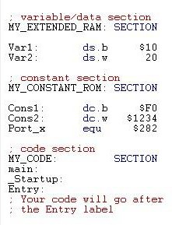

Linker Parameter File:
In the project window, the following file is automatically generated by CodeWarrior based on the derivative of chip selected. The linker parameter file uses a small control language designed to allow the user to direct the actions of the linker (or the compiler if it includes the linker). This file includes commands that map the memory for the derivative of chip selected, as well as information on what page of ROM that the program is flashed to and information about which memory locations are allocated to specific vectors in the vector map. For the HCS12E128, the addresses in the range from 0x0000 to 0x03FF are reserved for registers and I/O ports and are intentionally not defined. The addresses in the range from 0x0400 to 0x1FFF are reserved for RAM, with the addresses from 0x0400 to 0x04FF being reserved for space on the stack. There are eight 16 kb pages of ROM, with the program flashing by default to the addresses in the range from 0xC000 to 0xFEFF. The addresses in the range from 0xFF00 to 0xFFFF are reserved for the vector map and are important for moving the program counter to the correct location in the event of an interrupt event. Concepts such as the stack, the vector map, and interrupts will be discussed in future lab experiments. For now, be aware that this file is automatically generated, and it is vital for your program to properly function.

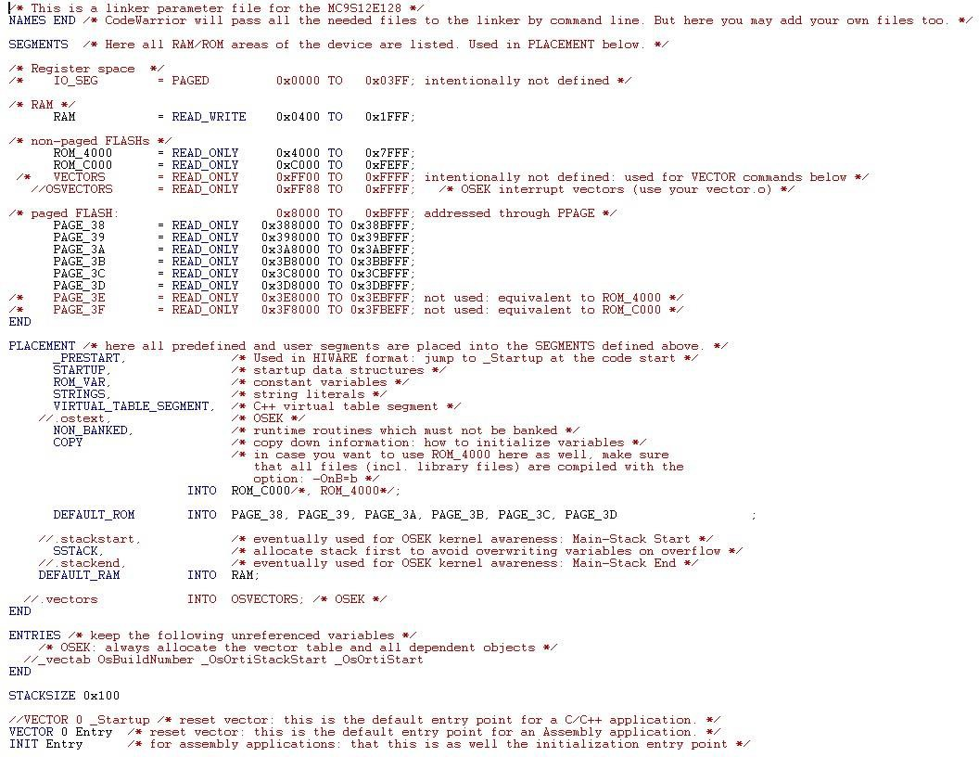
One last thing to note is the second line from the bottom: VECTOR 0 Entry. Vector 0 is associated with a power-on reset event. When the board is turned on, the program looks for the memory location associated with this vector and changes the program counter to this value. Any code written in labs should start at this label.

General Purpose Input/Output (GPIO):
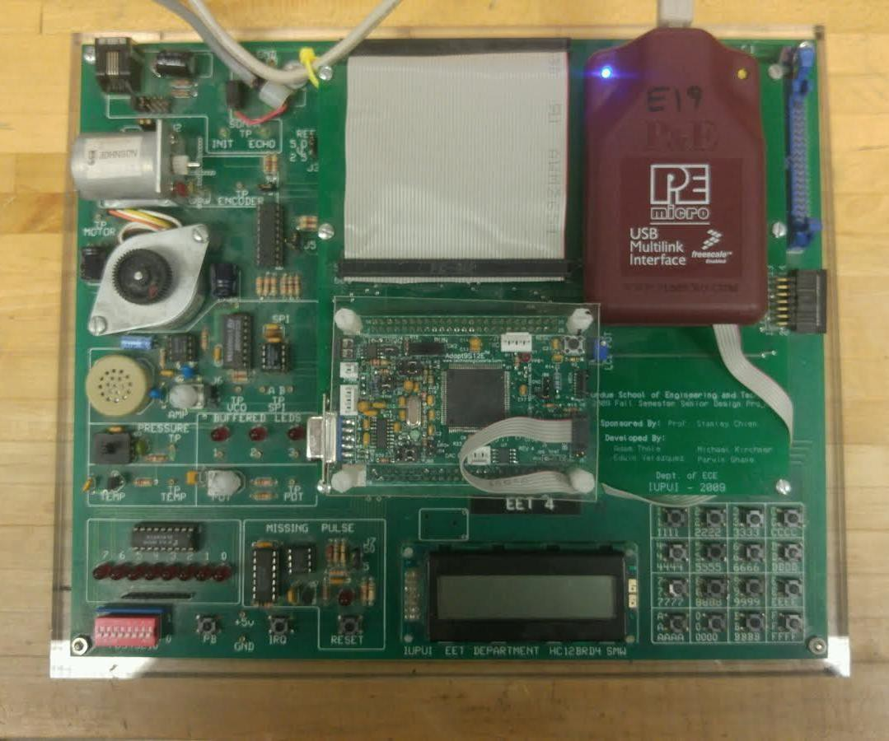
Above is the target microcontroller board and I/O board that will be used for the ECE 362 lab course. All of the I/O ports for the 68HCS12 are bidirectional, and default to function as an input. A catalog of the various peripherals that are used for this course is presented below:

Peripheral | Port
Dipswitches | Port T (b7 – b0)
LEDs | Port S (b7 – b0)
Stepper Motor | Port P (b5 – b1)
Keypad | Port U (b7 – b0)
Pushbutton | Port P (b6)
LCD | Port M (b7 – b0), Port AD (b15 – b0)
Potentiometer | Analog to Digital Conversion (ADC) Channel 0
Pressure Sensor | ADC Channel 1
Temperature Sensor | ADC Channel 2
DC Motor | Port T (b5)
Speaker (SPI) | Port S
Speaker | Port T (b3)

Notice that several peripherals can share the same port. One GPIO port can be used to drive several devices, given the requirements of using that device are met. Before using a port, it must be configured properly. Each port has several registers that are used for configuration purposes.
A summary of these registers is presented in the following table:

Register | Description
Data Direction Register (DDR) | This register configures port pins as either input or output.
Reduced Drive Register (RDR) | This register configures the drive strength of configured output pins as either full or reduced. If a pin is configured as input, the corresponding Reduced Drive Register bit has no effect.
Pull Device Enable Register (PER) | This register configures whether a pull-up or a pull-down device is activated on configured input pins. If a pin is configured as output, the corresponding Pull Device Enable Register bit has no effect.
Polarity Select Register (PPS) | Selects whether a pull-down or a pull-up device is connected  to the pin.

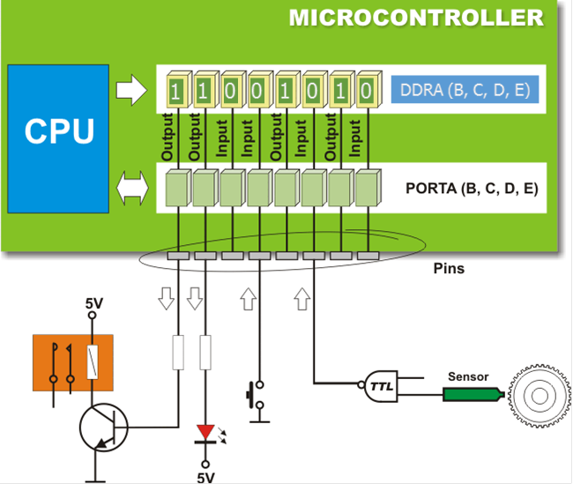
For this lab experiment, only the data direction register (DDR) will be used. Each pin of each port is bidirectional and can be used as either an input or an output. When configuring a pin of a port as an input, write a logic low to the corresponding pin of that port’s DDR. When configuring a pin of a port as an output, write a logic high to the corresponding pin of that port’s DDR. For example, if it is desired to make all of the pins of Port T (at address $240) an input, write the value $00 to the data direction register of Port T (at address $242). If it is desired to make all of the pins of Port S (at address $248) an output, write the value $FF = %11111111 to the data direction register of Port S (at address $24A).

Macros:
A macro allows a group of assembly instructions to be inserted into a program by specifying the macro name at the appropriate place to insert. Macros allow a program to be more easily read since a single meaningful statement can replace several lines of assembly code. Execution speed can be improved (at the expense of memory) if inline macro code replaces calls to subroutines. This macro execution speed would be no different than writing the code inline to begin with.
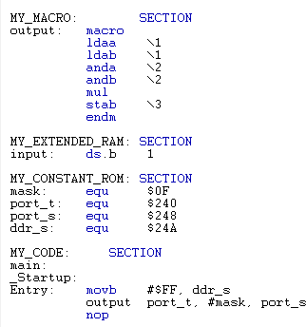
Above is an example macro. This macro is meant to read a value from Port T, mask the high nibble so that only a single hex digit is read, square this value, and store the result in Port S. A good way to format code is to include macros in their own section. There are more examples and information on macros available in the lecture slides.
Note: Because a macro takes multiple arguments and returns a value, students assume that macros are similar to functions in higher level programming languages, such as C. While there are similarities, functions in C are more like subroutines. Subroutines will be discussed in depth in Chapter 6, along with the stack.

Experimental Procedure:
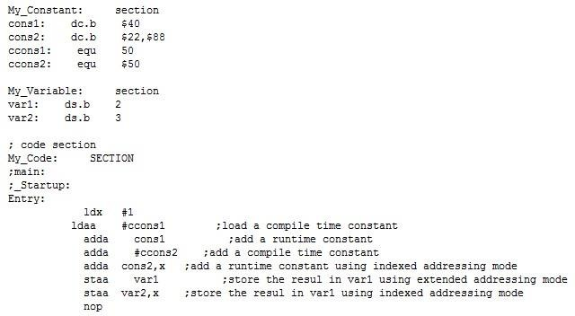
Laboratory 2.1.1: Download and extract the file Lab2-1 from Files > Labs > Lab 2 on Canvas. Note that the project will not run if still compressed. Open CodeWarrior and open this project by going to the directory you downloaded it to and double-clicking the Lab2-1.mcp file. In the left-hand window open the Sources folder and double-click on main.asm. Click make () to build the program and then click debug () to load the program into the target board. Make sure all of the registers and variables are shown in hexadecimal by right-clicking on registers and variables, and selecting Format > Hex. The main.asm file in Lab2-1 should be identical to what is presented below:

Set the PC and IP to 0xC000. Single step through the program, pay attention to the assembly and register windows, and answer the following questions:
- What value is in Index Register X after executing the first instruction? 1
  - What is the value of the Program Counter? C003
- What value is in Accumulator A after executing the second instruction? 32
  - What is the value of the Program Counter? C005
- What value is in Accumulator A after executing the third instruction? 72
  - What is the value of the Program Counter? C008
- What value is in Accumulator A after executing the fourth instruction? C2
  - What is the value of the Program Counter? C00A
- What value is in Accumulator A after executing the fifth instruction? 4A
  - What memory address does this data come from? C018
- Where are the contents of Accumulator A stored after instruction 6? 4A
- Where are the contents of Accumulator A stored after instruction 7? 4A

Laboratory 2.1.2: Modify the code in the previous section to match the code presented below, build and step through the program using the debugger, and answer the following questions.
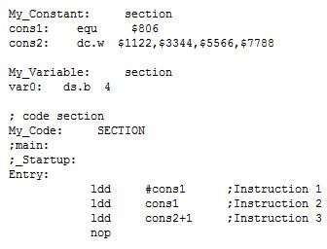

- What are the contents of Accumulator D after execution of instruction 1? 806
  - What addressing mode is used in instruction 1? Immediate
  - What address did the data come from (could be in code or memory)? C001-C002
- What are the contents of Accumulator D after execution of instruction 2? 5A5A
  - What addressing mode is used in instruction 2? Extented
  - What address did the data come from? 806
- What are the contents of Accumulator D after execution of instruction 3? 2233
  - What addressing mode is used in instruction 3? Extended
  - What address did the data come from? C00B-C00C

Laboratory 2.1.3: Modify the main.asm file in the Lab2-1 project to accomplish the following:
- Use the assembler directive dc.b to define three constants cons1, cons2, and cons3
with initial values of $11, $3c, and 36 respectively.
- Use the assembler directive ds.b to define two 1 byte variables var1 and result.
- Calculate the sum of the initialized bytes in cons1, cons2, and cons3.
- Store the result to the variable result.
- Place a NOP (no operation) instruction as the last executable statement.
- Assemble the program, load is into the debugger, and then step through the program to the NOP instruction.
- What is the sum of the three variables in hexadecimal? 71
- Verify that the answer is properly stored by examining the contents of the variable result after stepping through the program. Double click on a variable to monitor the contents of variables.

Laboratory 2.2.1:
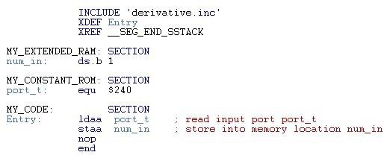

Why doesn’t the ldaa port_t instruction have a # sign in front of the operand?
You are trying to load the address of port_t to Accumulator A not the value its stores.

This program reads the switches from the evaluation board and stores their value in Accumulator
A. The switches are accessed via I/O Port T (Address $240). Switch 0 corresponds with the LSB (b0). Switch 1 corresponds with bit position 1 (b1). Switch 2 corresponds with b2, and switch 3 corresponds with b3. The program sets the constant port_t equal to $240, a useful practice to improve readability. Type the program above into CodeWarrior. Compile and link the program.

Important: The switches are located in the lower left corner of the lower board. The switch components are removable. Do not remove this component or change the switch positions of the switch block on the upper board. If you have any problems, notify a lab instructor.
Run the previous program four times, changing the values of the dip switches as specified. Record the value stored in the variable “num_in” after each run.
SW3 | SW2 | SW1 | SW0 | Binary Code (num_in)
on | on | off | on | 1101
off | on | on | off | 0110
off | off | on | off | 0010
on | off | off | on | 1001

Laboratory 2.2.2: Write a program to read the switches of Port T (address $240) from the evaluation board. Add 3 to the value read from the switches and write the resulting value to the board’s LEDs. The LEDs can be accessed via Port S (address $248). To make port S an output port, add code to your program that writes the immediate value #$FF to the DDR of port S (address
$24A).

Reminder: The pins of I/O ports on the HC(S)12 are bidirectional (input or output; not concurrent). By default, the bidirectional pins of ports are inputs. A data direction register used to program the I/O direction is associated with each register. To make a pin (bit) of a port an output, write a 1 to the corresponding bit in the data direction register.

Laboratory 2.2.3: Write a program that reserves an uninitialized byte variable in memory using the ds.b assembler directive and label this variable “ADDEND”. Initialize all of the bits of port S as outputs. Read the switches at port T (address $240) from the evaluation board, add the contents of “ADDEND” to the value read from the switches, and write the resulting value to the LEDs at port S (address $248). Remember to make port S an output by writing all ones to the data direction register for port S at address $24A.
Note: Since ADDEND is uninitialized, the debugger can be used to put different values in addend each time the program is executed. To modify a variable, place the cursor on the variable in the data window, double clicking, and typing in the new data.

Laboratory 2.3: Write a program using a macro that can read data from any specified port and then write that data to another specified port. The two ports should be specified in the single line macro call. Test this program by reading the switches at Port T (address $240) and then writing to the LEDs at Port S (address $248). Make sure Port S at address $248 is an output. In addition, write another macro call that will take a predefined value from memory and write that value to a specified port. Test the program.
When debugging the above programs, put the source code window in the assembly mode so the expanded code generated by the macro can be viewed.

